CM3025 - Virtual Reality
By David Della Rossa

Technical plan

Overview
Simon Plays is a puzzle/memory game in VR, where the player tests her memory, by reproducing progressively complicated patterns of sounds and colours trying no to make mistakes.
The game proposes a sequence of notes or colours on a screen and the player is expected to repeat the same sequence on a console. If the sequence reproduced is correct, the player advances to the next level, otherwise she loses.
The more the player advances in the game, the more complex the sequences to reproduce become.

Key technologies
The game is developed using Unity 3d as a game engine/editor.
The virtual reality hardware in use is the Valve Index.
At the time of writing, Valve Index is one of the most advanced VR systems, with a high resolution display with up to 120Hz refresh rate, a resolution of 1600x1440 per eye, two off-ear speakers providing a high level of immersion without tiring the ears.
The controllers also are pretty advanced, being able to detect the position of each finger independently, allowing gestures like grabbing and throwing in a more natural way.
Valve also provides an SDK for Valve Index, which makes use of the same SteamVR component used by all VR games distributed on the Steam platform.
The SDK is distributed on the Unity Asset Store and is easily and quickly downloadable with a few clicks.
Once installed, it also provides a test scene with some ready-made examples of interactions and some models for gloves and controllers.
Configuring the game for using this SDK is quite easy as it is all documented here.

Interaction techniques
My game will not require a seated or standing posture. No walking required.
The player stands in front of a console, offering four coloured buttons.
Further ahead the player sees a wall mounted display with four big coloured areas, with the same colour configuration as the buttons on the console.
When the game starts, the wall-mounted displays light-on, and emit a sound, in a progressively more complex pattern.
The player has to reproduce the same pattern, in a given amount of time, on the console, by pressing the big buttons with her fingers.
If the sequence is correct, the next pattern becomes longer. If the sequence input is incorrect, the game is lost.

For the first prototype, wall-mounted displays and the console will have only four buttons.
However, a different button configuration, resembling a piano keyboard, would allow more interesting patterns of sounds, more than visual. This would be very useful for ear training and recognition of scales, chords, arpeggios, etc.

Assets
The assets I’m using are those provided by the Valve Index SDK.

Project evaluation
In the second part of the course, after the Mid-Term deadline, I plan to create a build of the game and ask for a few fellow students, or colleagues to voluntarily offer to test the game.
I plan to produce three versions of the game during the second part of the project.
The testers will do their evaluation purely on a voluntary basis. No form of remuneration will be given.
When they are ready to provide their feedback, a brief questionnaire will be provided, where they can share their thoughts and ideas on improvements, or notify bugs or any type of malfunctioning.
This feedback will then be evaluated and the proper actions will be taken to put tester’s suggestions in the game’s next version.

Further information
For further information about the game design, please see the github wiki.
For further information about the project management, please see the github project.
For further information about the source code, please see the github repository.
Note: all these links point to resources which are all Work-In-Progress. The Information therein contained can therefore change at any moment without any type of notice, until the project deadline.

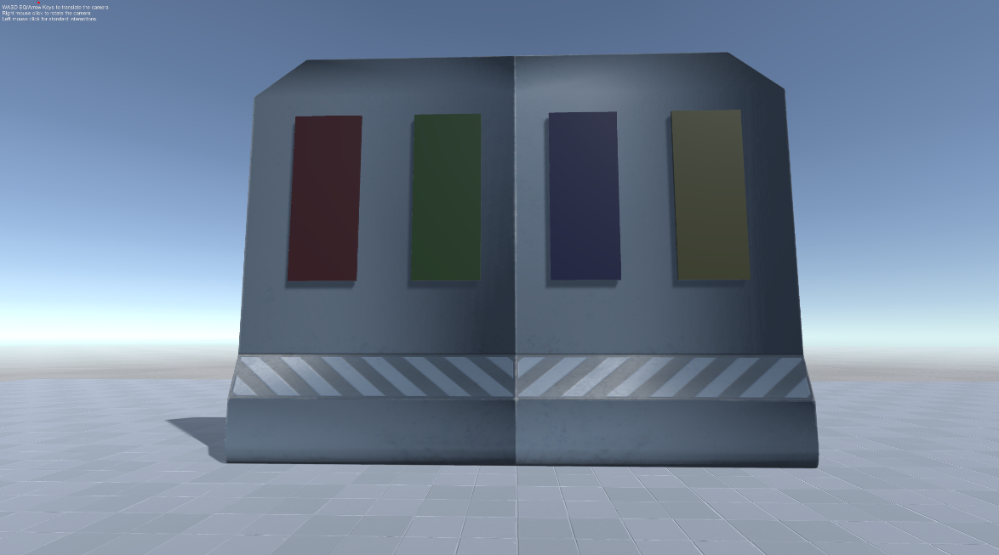
The wall-mounted panels
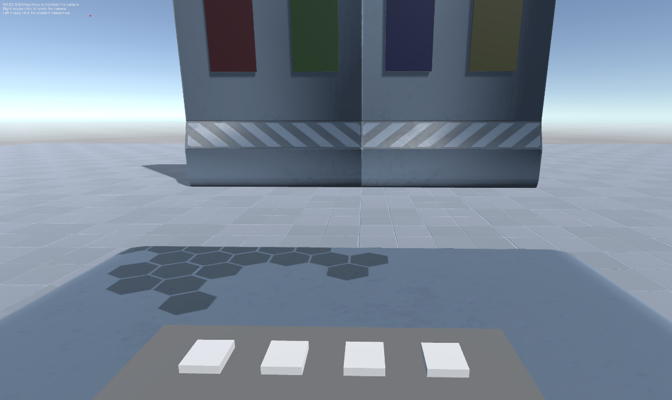
The console

